**ASSIGNMENT-12**

U19CS012

**1.** Solve for output Function/Functions. Also verify the same using Multisim.



“A” Batch Question

**Circuit Diagram [Multisim Implementation]**

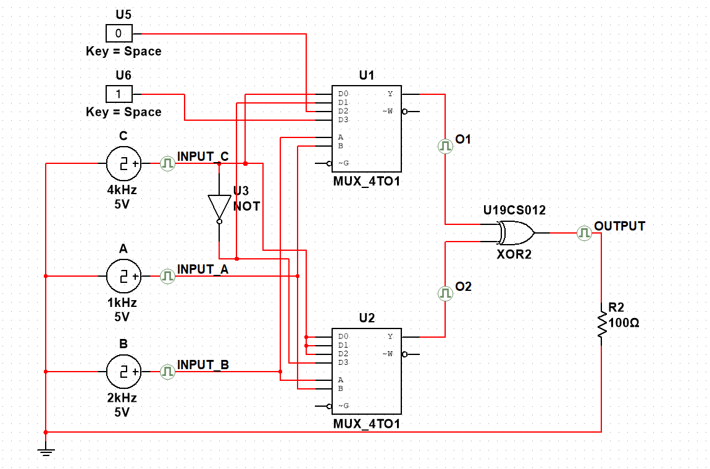

**Grapher Image [Transient]**

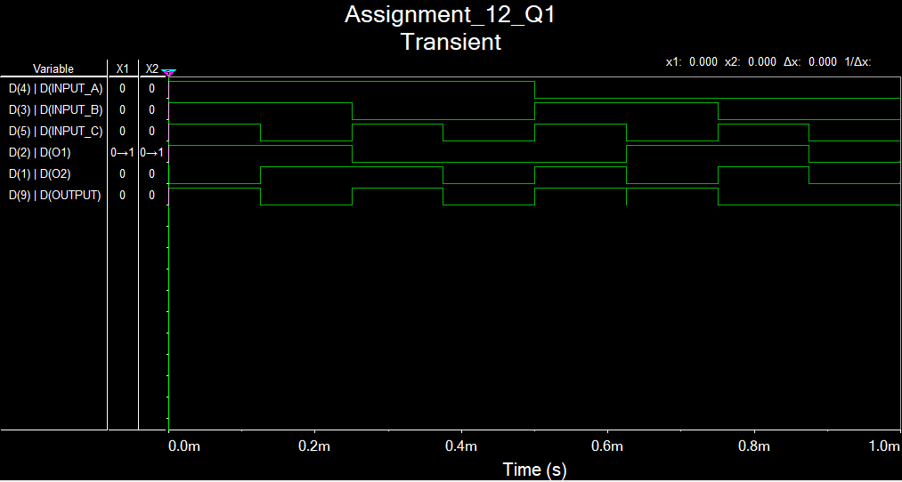

**Theoretical Solution**

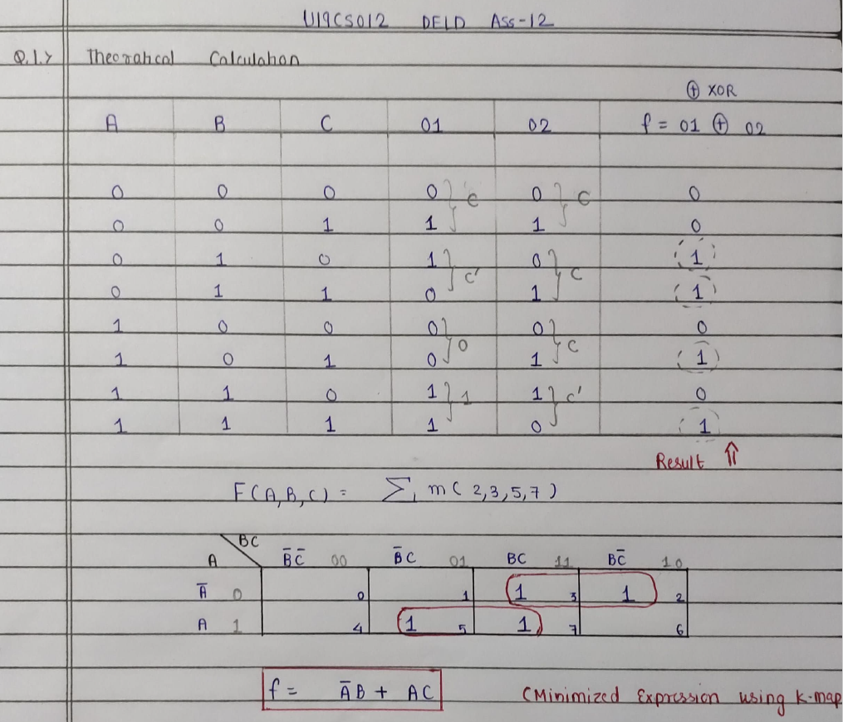

**2.** Design, implement and verify using Multisim: BCD to Excess – 3 Code Converter



**Theoretical Solution**

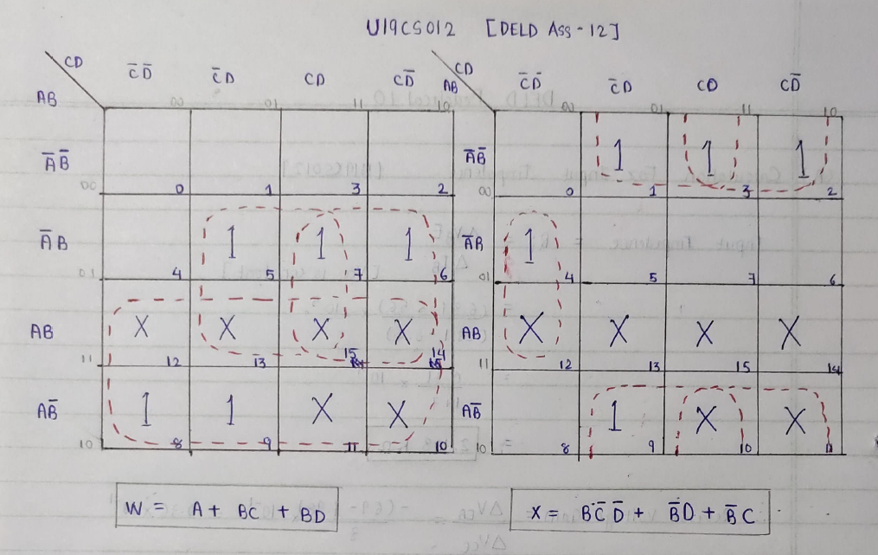

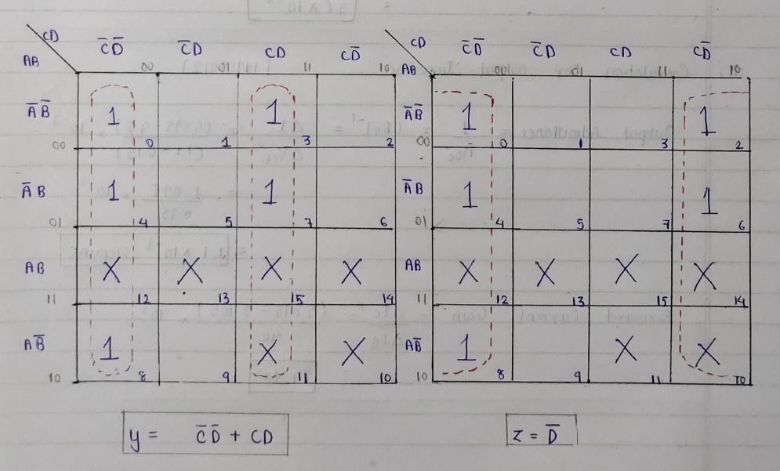

**Circuit Diagram [Multisim Implementation]**

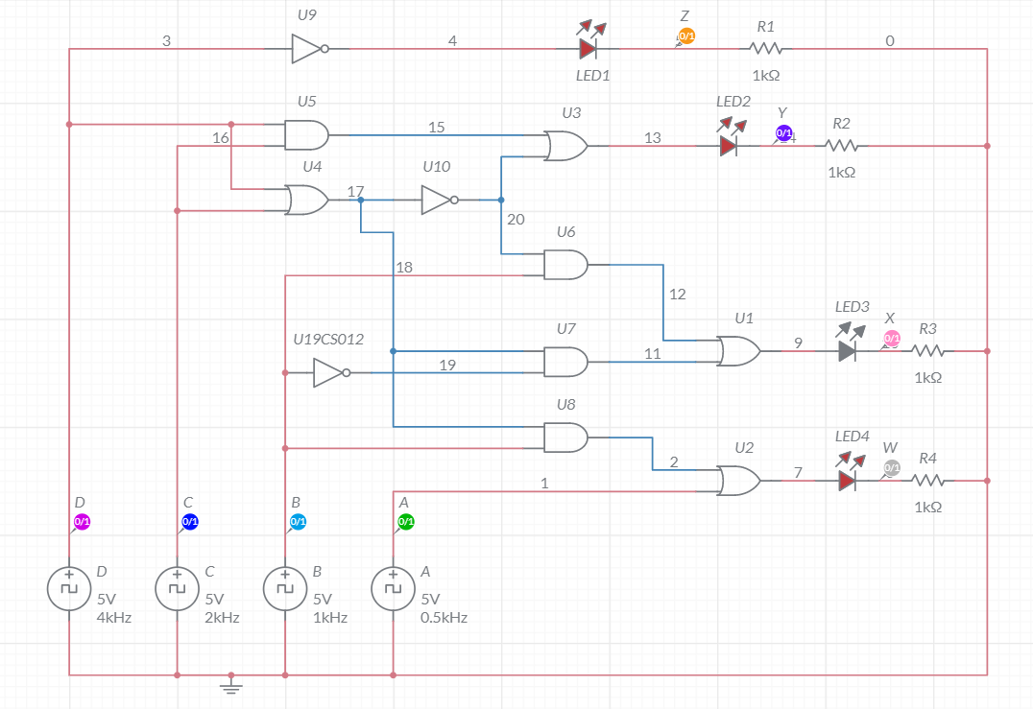

**Grapher Image [Transient]**

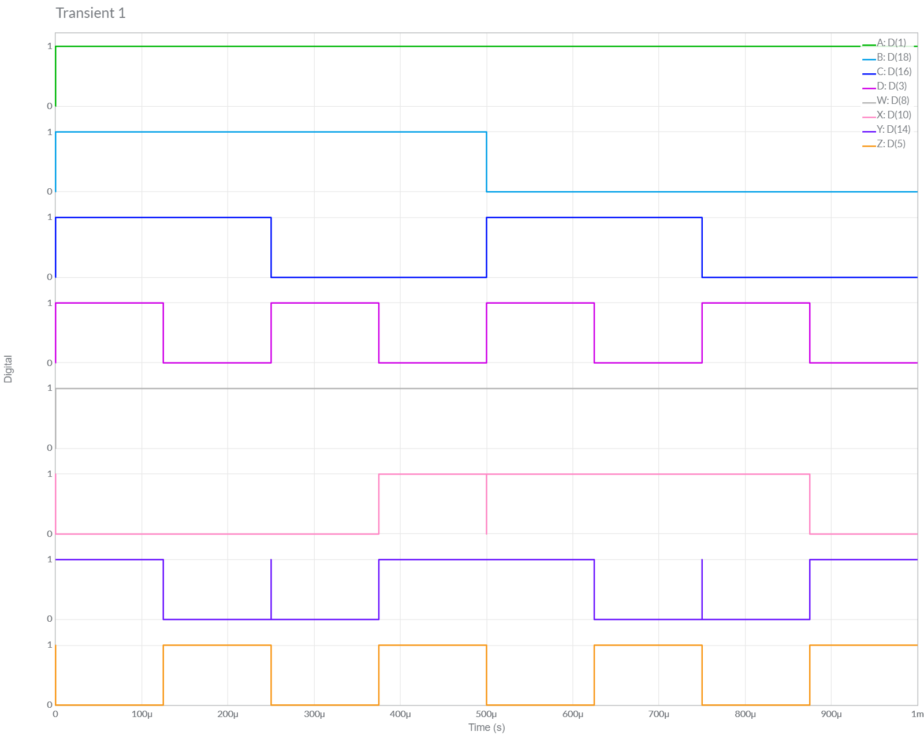

*D.) CONCLUSION:*

We have Successfully Implemented *Particular Circuit [A’B + AC] and BCD to Excess-3 Convertor* and **verified** our **MULTISIM Outputs** and **Results** from *Theoretical Calculations.*

*Hence Results Both Theoretical Calculation and Multisim Implementation have been verified to be* ***same*** *and The Experiment has Been Successfully Performed.*